NUCLEAR REACTORS

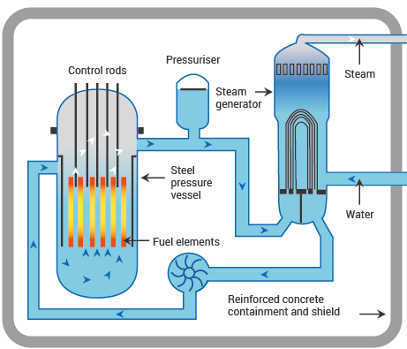

Nuclear reactors are **the heart of a nuclear power plant**. They contain and control nuclear chain reactions that produce heat through a physical process called fission. That heat is used to make steam that spins a turbine to create electricity

COMPONENTS

* Core
* Reflector
* Control Rods
* Moderator
* Coolant
* Turbine
* Containment
* [Cooling Towers](https://www.elprocus.com/what-is-a-cooling-tower-components-construction-applications/)
* Shielding

WORKING MECHANISM

The main job of a reactor is to house and control nuclear fission—a process where atoms split and release energy.

Reactors use uranium for nuclear fuel. The uranium is processed into small ceramic pellets and stacked together into sealed metal tubes called fuel rods. Typically, more than 200 of these rods are bundled together to form a fuel assembly. A reactor core is typically made up of a couple hundred assemblies, depending on power level.

Inside the reactor vessel, the fuel rods are immersed in water which acts as both a coolant and moderator. The moderator helps slow down the neutrons produced by fission to sustain the chain reaction.

Control rods can then be inserted into the reactor core to reduce the reaction rate or withdrawn to increase it.

The heat created by fission turns the water into steam, which spins a turbine to produce carbon-free electricity.

TYPES OF NUCLEAR REACTOR

* [CANDU reactors](https://energyeducation.ca/encyclopedia/CANDU_reactor)
* [Fast breeder reactors](https://energyeducation.ca/wiki/index.php?title=Fast_breeder_reactor&action=edit&redlink=1)
* [Thorium reactors](https://energyeducation.ca/wiki/index.php?title=Thorium_reactor&action=edit&redlink=1)
* [Boiling water reactors](https://energyeducation.ca/encyclopedia/Boiling_water_reactor)
* [Pressurized water reactors](https://energyeducation.ca/encyclopedia/Pressurized_water_reactor) / [Prismatic reactors](https://energyeducation.ca/wiki/index.php?title=Prismatic_reactors&action=edit&redlink=1)
* [Molten salt reactors](https://energyeducation.ca/encyclopedia/Molten_salt_reactor)
* [Small modular reactors](https://energyeducation.ca/wiki/index.php?title=Small_modular_reactor&action=edit&redlink=1)
* [Radioisotope thermal generators](https://energyeducation.ca/encyclopedia/Radioisotope_thermal_generator)
* [Fusion reactors](https://energyeducation.ca/wiki/index.php?title=Fusion_reactor&action=edit&redlink=1)

The **applications of nuclear reactor** include the following

* These are used at nuclear power plants to generate electricity & also used in nuclear marine propulsion.
* Nuclear power plants supply the required energy to produce electrical energy.
* These drive the propellers of ships otherwise to turn the shafts of electrical generators.

## **What Is Paper Chromatography?**

Chromatography technique that uses paper sheets or strips as the adsorbent being the stationary phase through which a solution is made to pass is called paper chromatography. It is an inexpensive method of separating dissolved chemical substances by their different migration rates across the sheets of paper. It is a powerful analytical tool that uses very small quantities of material.

## **Paper Chromatography Principle**

The principle involved can be partition chromatography or adsorption chromatography. Partition chromatography because the substances are partitioned or distributed between liquid phases. The two phases are water held in pores of the filter paper and the other phase is a mobile phase which passes through the paper. When the mobile phase moves, the [separation of the mixture](https://byjus.com/chemistry/separation-of-mixtures/) takes place. The compounds in the mixture separate themselves based on the differences in their affinity towards stationary and mobile phase solvents under the capillary action of pores in the paper. Adsorption chromatography between solid and liquid phases, wherein the solid surface of the paper is the stationary phase and the liquid phase is the mobile phase.

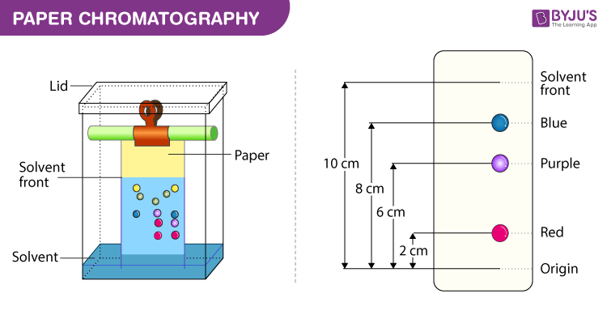

## **Paper Chromatography Procedure**

Below we have explained the procedure to conduct Paper Chromatography Experiment for easy understanding of students.

1. **Selecting a suitable type of development:**It is decided based on the complexity of the solvent, paper, mixture, etc. Usually ascending type or radial paper chromatography is used as they are easy to perform. Also, it is easy to handle, the chromatogram obtained is faster and the process is less time-consuming.
2. **Selecting a suitable filter paper**: Selection of filter paper is done based on the size of the pores and the sample quality.
3. **Prepare the sample:** Sample preparation includes the dissolution of the sample in a suitable solvent (inert with the sample under analysis) used in making the mobile phase.
4. **Spot the sample on the paper:** Samples should be spotted at a proper position on the paper by using a capillary tube.
5. **Chromatogram development:** Chromatogram development is spotted by immersing the paper in the mobile phase. Due to the capillary action of paper, the mobile phase moves over the sample on the paper.
6. **Paper drying and compound detection**: Once the chromatogram is developed, the paper is dried using an air drier. Also, detecting [solution](https://byjus.com/chemistry/solution-properties-concentration/) can be sprayed on the chromatogram developed paper and dried to identify the sample chromatogram spots.

## **Paper Chromatography Applications**

There are various [applications of paper chromatography](https://byjus.com/chemistry/separation-of-pigments-of-leaves-and-flowers-by-chromatography/). Some of the uses of Paper Chromatography in different fields are discussed below:

* To study the process of fermentation and ripening.
* To check the purity of pharmaceuticals.
* To inspect cosmetics.
* To detect the adulterants.
* To detect the contaminants in drinks and foods.
* To examine the reaction mixtures in biochemical laboratories.
* To determine dopes and drugs in humans and animals.

## **Types of paper chromatography:**

1. Ascending Paper Chromatography – The techniques goes with its name as the solvent moves in an upward direction.
2. Descending Paper Chromatography – The movement of the flow of solvent due to gravitational pull and capillary action is downwards, hence the name descending paper chromatography.

**nuclear fission**, subdivision of a heavy atomic nucleus, such as that of [uranium](https://www.britannica.com/science/uranium) or [plutonium](https://www.britannica.com/science/plutonium), into two fragments of roughly equal mass. The process is accompanied by the release of a large amount of [energy](https://www.britannica.com/science/energy).

In nuclear fission the nucleus of an [atom](https://www.britannica.com/science/atom) breaks up into two lighter nuclei. The process may take place spontaneously in some cases or may be [induced](https://www.britannica.com/dictionary/induced) by the excitation of the nucleus with a variety of particles (e.g., neutrons, [protons](https://www.britannica.com/science/proton-subatomic-particle), [deuterons](https://www.britannica.com/science/deuteron), or alpha particles) or with [electromagnetic radiation](https://www.britannica.com/science/electromagnetic-radiation) in the form of [gamma rays](https://www.britannica.com/science/gamma-ray). In the fission process, a large quantity of energy is released, radioactive products are formed, and several neutrons are emitted. These neutrons can induce fission in a nearby nucleus of [fissionable material](https://www.britannica.com/technology/fissile-material) and release more neutrons that can repeat the sequence, causing a [chain reaction](https://www.britannica.com/science/nuclear-chain-reaction) in which a large number of nuclei undergo fission and an enormous amount of energy is released. If controlled in a nuclear reactor, such a chain reaction can provide [power](https://www.britannica.com/science/power-physics) for society’s benefit. If uncontrolled, as in the case of the so-called [atomic bomb](https://www.britannica.com/technology/atomic-bomb), it can lead to an explosion of awesome destructive [force](https://www.britannica.com/science/force-physics).

## **What Is Thin Layer Chromatography?**

Thin Layer Chromatography is a technique used to isolate non-volatile mixtures. The experiment is conducted on a sheet of aluminium foil, plastic, or glass which is coated with a thin layer of adsorbent material. The material usually used is [aluminium oxide](https://byjus.com/chemistry/al2o3/), cellulose, or silica gel.

On completion of the separation, each component appears as spots separated vertically. Each spot has a retention factor (Rf) expressed as:

Rf = dist. travelled by sample / dist. travelled by solvent

The factors affecting retardation factor are the solvent system, amount of material spotted, adsorbent and temperature. TLC is one of the fastest, least expensive, simplest and easiest chromatography technique.

## **Thin Layer Chromatography Principle**

Like other chromatographic techniques, thin-layer chromatography (TLC) depends on the separation principle. The separation relies on the relative affinity of compounds towards both the phases. The compounds in the mobile phase move over the surface of the stationary phase. The movement occurs in such a way that the compounds which have a higher affinity to the stationary phase move slowly while the other compounds travel fast. Therefore, the [separation of the mixture](https://byjus.com/chemistry/separation-of-mixtures/) is attained. On completion of the separation process, the individual components from the mixture appear as spots at respective levels on the plates. Their character and nature are identified by suitable detection techniques.

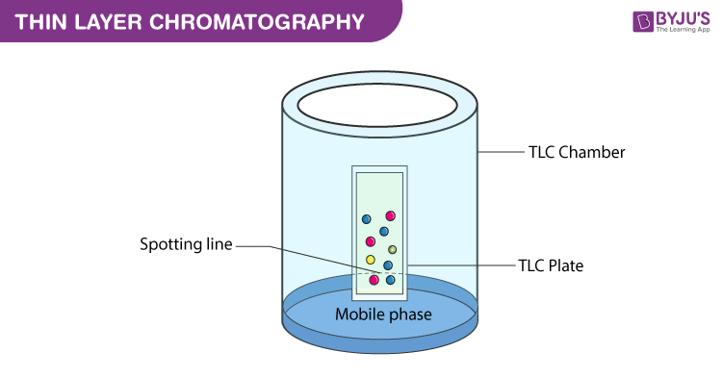

## **Thin Layer Chromatography Procedure**

Before starting with the Thin Layer Chromatography Experiment, let us understand the different components required to conduct the procedure along with the phases involved.

1. Thin Layer Chromatography Plates – ready-made plates are used which are chemically inert and stable. The stationary phase is applied on its surface in the form of a thin layer. The stationary phase on the plate has a fine particle size and also has a uniform thickness.
2. Thin Layer Chromatography Chamber – Chamber is used to develop plates. It is responsible to keep a steady environment inside which will help in developing spots. Also, it prevents the solvent evaporation and keeps the entire process dust-free.
3. Thin Layer Chromatography Mobile phase – Mobile phase is the one that moves and consists of a solvent mixture or a solvent. This phase should be particulate-free. The higher the quality of purity the development of spots is better.
4. Thin Layer Chromatography Filter Paper – It has to be placed inside the chamber. It is moistened in the mobile phase.

## **Thin Layer Chromatography Applications**

* The qualitative testing of Various medicines such as sedatives, local anaesthetics, anticonvulsant tranquilisers, analgesics, antihistamines, steroids, hypnotics is done by TLC.
* TLC is extremely useful in Biochemical analysis such as separation or isolation of biochemical metabolites from its blood plasma, urine, body fluids, serum, etc.
* Thin layer chromatography can be used to identify natural products like essential oils or volatile oil, fixed oil, glycosides, waxes, alkaloids, etc.

APPLICATION OF IR

## Measuring environmental pollutants

High sensitivity and selectivity make IR Spectroscopy for analysing complex mixtures. The technique has become a mainstay in for environmental scientists, who use it to detect industrial pollutants in the atmosphere.

## Preserving contemporary artworks

Preserving contemporary artworks has recently emerged as a novel use for IR Spectroscopy. In a study published in the journal Scientific Reports, the authors introduce IR Spectroscopy as a technique to detect and quantify plasticisers such as phthalates, adipates, terephthalates and citrates in PVC objects of historic value.

**2. Identification of substances**

IR spectroscopy is used to establish whether a given sample of an organic substance is identical with another or not. This is because large number of absorption bands is observed in the IR spectra of organic molecules and the probability that any two compounds will produce identical spectra is almost zero. So if two compounds have identical IR spectra then both of them must be samples of the same substances.

**4. Detection of impurities**

IR spectrum of the test sample to be determined is compared with the standard compound. If any additional peaks are observed in the IR spectrum, then it is due to impurities present in the compound.

**5. Quantitative analysis**

The quantity of the substance can be determined either in pure form or as a mixure of two or more compounds. In this, characteristic peak corresponding to the drug substance is chosen and log I0/It of peaks for standard and test sample is compared. This is called base line technique to determine the quantity of the substance.

The basic principle shared by all spectroscopic techniques is **to shine a beam of electromagnetic radiation onto a sample, and observe how it responds to such a stimulus**. The response is usually recorded as a function of radiation wavelength.

chromatography, technique for separating the components, or solutes, of a mixture on the basis of the relative amounts of each solute distributed between a moving fluid stream, called the mobile phase, and a contiguous stationary phase.

Alpha particles are subatomic fragments consisting of **two neutrons and two protons**.

**beta radiation is the emission of electrons or positrons , and gamma radiation is the term used for the emission of energetic photons**.

The principle of Auger operates by **allowing a high-energy electron from the beam to eject an electron from its orbit creating an empty hole in the orbit**. As this occurs, another electron from a higher orbit moves to fill the empty space. As the electron changes from a higher to a lower orbit, it releases energy.